TASK 1:
INCLUDE Irvine32.inc

.data
prompt byte "Enter Four integers: ", 0
userInt dword 4 DUP(?)
prompt2 byte "Equal Integer Found", 0
.code
main PROC
mov eax, 0
mov ebx, 0
mov ecx, 4

mov edx, offset prompt
call writestring
call crlf

mov edx, offset userInt
l1:
call readint
mov [edx], eax
add edx, 4
loop l1

mov ecx, lengthof userInt - 1
mov edx, offset userInt
l2:
mov eax, [edx]
cmp eax, [edx+4]
je quit1
add edx, 4
loop l2

quit1:
mov edx, offset prompt2
call writestring
call crlf

exit
main ENDP
END main

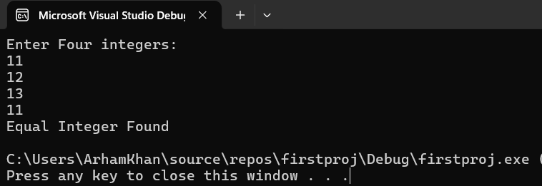
TASK 2:
INCLUDE Irvine32.inc

.data

intArr sword 0, 0, 0, 150, 120, 35, -12, 66, 4, 0
prompt byte "Found at Index: ", 0
.code
main PROC
mov eax, 0
mov ebx, 0

mov ecx, lengthof intArr
mov edx, offset intArr
l1:
movsx eax, word PTR [edx]
mov ebx, lengthof intArr
sub ebx, ecx
cmp eax, 0
jnz found
add edx, 2
loop l1

found:
mov edx, offset prompt
call writestring
call crlf
mov eax, ebx
call writedec

exit
main ENDP
END main

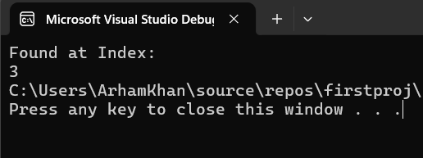
TASK 3:
INCLUDE Irvine32.inc

.data
x dword ?
var = 5
intArr sword 0, 0, 0, 150, 120, 35, -12, 66, 4, 0
prompt1 byte "Condition is true ", 0
prompt2 byte "Condition is False ", 0
.code
main PROC
mov eax, 0
mov ebx, 0

mov eax, var
add eax, 1
mov edx, eax

mov ecx, lengthof intArr
mov eax, var
cmp eax, ecx ; 1st condition
ja cond2
jmp else_block

cond2: ; 2nd condition
cmp ecx, edx
jge cond_satisfied
jmp else_block

cond_satisfied:
mov ebx, 0
mov x, ebx
cmp x, 0
jnz else_block

cond_true:
mov edx, offset prompt1
call writestring
call crlf
jmp quit

else_block:
mov ebx, 1
mov x, ebx
mov edx, offset prompt2
call writestring
call crlf
jmp quit

quit:

exit
main ENDP
END main

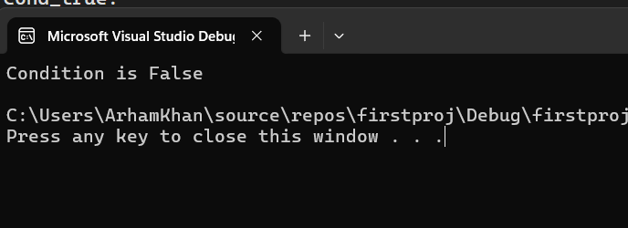
TASK 4:
INCLUDE Irvine32.inc

.data
var dword 0
str1 byte "Hello World! ", 0
str2 byte "Condition False", 0
.code
main PROC
mov eax, 0
mov eax, [var]

cmp eax, 10
jg _endwhile
cmp eax, 5
jb if_block
jmp else_block
if_block:
mov ebx, [var]
add ebx, 1
mov [var] , ebx
mov ecx, 5
l1:
mov edx, offset str1
call writestring
call crlf
loop l1

else_block:
mov ebx, [var]
add ebx, 1
mov [var] , ebx

mov ecx, 6
l2:
mov edx, offset str2
call writestring
call crlf
loop l2

_endwhile:

exit
main ENDP
END main
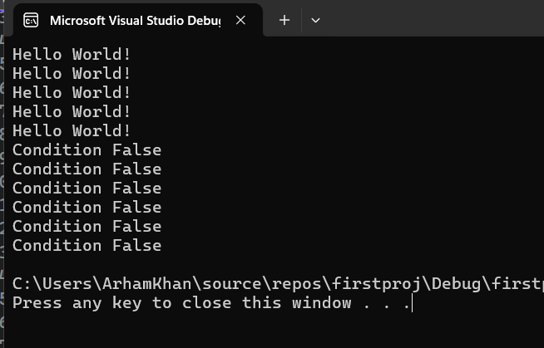

TASK 5:
INCLUDE Irvine32.inc
.data
msg byte "Enter Number for Day: ", 0
Monday byte "Monday", 0
tue byte "Tuesday", 0
wed byte "Wednesdsay", 0
thu byte "Thursday", 0
fri byte "Friday", 0
sat byte "Saturday", 0
sun byte "Sunday", 0
error1 byte "Invalid Day", 0

.code
main PROC

mov edx, offset msg
call writestring
call crlf
call ReadInt
mov ebx, 1
cmp eax, ebx
jb NF
ja CheckTue
mov edx, offset Monday
jmp L1
CheckTue:
inc ebx
cmp eax, ebx
jb NF
ja CheckWed
mov edx, offset tue
jmp L1
CheckWed:
inc ebx
cmp eax, ebx
jb NF
ja CheckThurs
mov edx, offset wed
jmp L1
CheckThurs:
inc ebx
cmp eax, ebx
jb NF
ja CheckFri
mov edx, offset thu
jmp L1
CheckFri:
inc ebx
cmp eax, ebx
jb NF
ja CheckSat
mov edx, offset fri
jmp L1
CheckSat:
inc ebx
cmp eax, ebx
jb NF
ja CheckSun
mov edx, offset sat
jmp L1
CheckSun:
inc ebx
cmp eax, ebx
jne NF
mov edx, offset sun
jmp L1
NF:
mov edx, offset error1
L1:
call writestring
call CRLF
exit

main ENDP
END main

